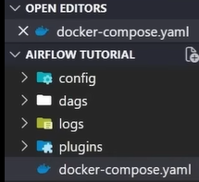
STEPS FOR FOLDAR CREATION IN VS CODE FOR AIR FLOW:
1: Open VS code and create Directory like Project Folder (Airflow tutorial)
2 : Create 4 Folder in the root directory, logs, dags, config, plugin -----------------
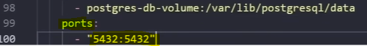
3 : Go to browser and find airflow docker compose to get yaml file and put in the project root directory.
4 : update this yaml file -
Add ports:5432 and load_example=false
5 : Create Virtual own environment – (1) open Terminal – pip install uv (2) uv init – It will create
(3) uv sync – It will sink all dependency and will create virtual environment automatically
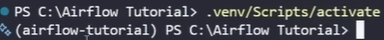
6: Close terminal and open again it will automated enable virtual environment of not unlabeled then do manually - .venv/Scripts/activate and hit enter
7: Now I’m in the virtual environment not global environment then uv add apache-airflow it will download package for my environment
8: In plugin folder create one .env file and write in files – AIRFLOW_UID =50000
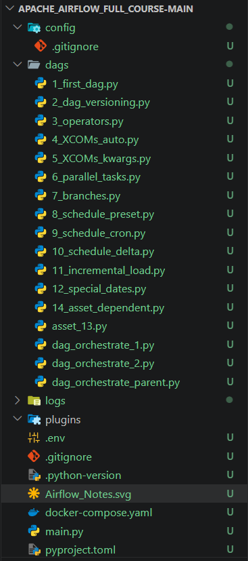
8: docker compose up -d (for start docker) docker compose down (for stop docker compose)
9: Now ready to create dags files:

